DEUTSCH FÜR KINDER
A special German language program for children offered by advanced German students at Freedom High School
German is Fun
Session 1: Ja Nein
basic greeting, say your name, count to 10
Greeting & Introductions
German | Pronunciation | English
Hallo | hulow | Hello
Wie heisst du? | vee heisst doo | What is your name?
Ich heisse | eech heissuh | My name is
Wie alt bist du? | vee ult beest doo | How old are you?
Ich bin ... | eech been | I am
Guten Tag | gootun tuck | Good Day
Wie geht's (dir)? | vee gates dea(r) | How are you doing?
Danke, gut | donka, goot | Thank you, I am fine
Und dir? | oont dea(r) | And you (how are you going)?
Lied Song
German  Ich heisse Moritz,  Hallo, wie heisst du, wie heisst du?  Ich heisse Moritz, wie geht's  Gut, sehr gut. | Pronunciation  Eech haissa Mooreets  Hulow, vee haist doo  eech haissa Moreets, vee gates  goot, zea goot

Zahlen Numbers
German | Pronunciation
1 eins | oins
2 zwei | swoy
3 drei | dry
4 vier | fea(r)
5 fünf | feenf
6 sechs | zaxs
7 sieben | sseabun
8 acht | aucht
9 neun | noin
10 zehn | tsaehn
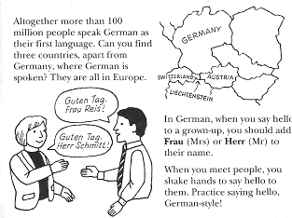
Zahlen Reim Numbers Rhyme
German | Pronunciation
Eins, zwei drei vier fünf sechs sieben;  eine alte Frau kocht Rüben,  eine alte Frau kocht Speck,  und du bist weg. | oina ultu frow kucht reebun,  oina ultu frow kucht shpeck,  oont doo beast vack.

“Willkommen “ to our special German program. At the end of this program, you and your child will be able to speak and understand basic German.

The key to success is practice. Therefore, each session comes with a handout which includes the words and phrases your child has learned. Encourage your child to repeat the phrases to you and teach you the song. Also, be sure to visit our website which accompanies the program:

Go to: http://www.burke.k12.nc.us/fhs/teacherpage/koerner/index.html
Select “D für Kinder” from the linkbar at the top
Select this program: “German is Fun”
Explore
® Joachim Körner, 7/31/2026

