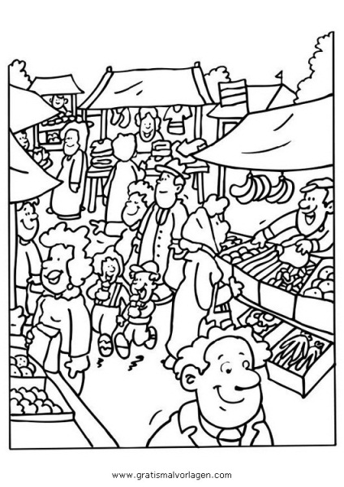**Einkaufen auf dem Markt (Script**)

<http://www.youtube.com/watch?v=99NJVkqTyhE>

|  |  |  |
| --- | --- | --- |
| Function | A Customer | B Salesperson |
| Greeting |  |  |
| Offering Service |  |  |
| Polite request |  |  |
| Offering anything else |  |  |
| Polite request |  |  |
| Turning down request counter offer |  |  |
| Accept/ asking for price |  |  |
| Quoting the price |  |  |
| Accepting and Requesting |  |  |
| Offering Sample |  |  |
| Accepting, asking for something else |  |  |
| Declining request |  |  |
| Requesting instead |  |  |
| Offering anything else |  |  |
| Turning down request asking for price |  |  |
| Telling total price |  |  |
| Counting money |  |  |
| thanks |  |  |
| welcome |  |  |
| Good bye |  |  |